* **Backend**

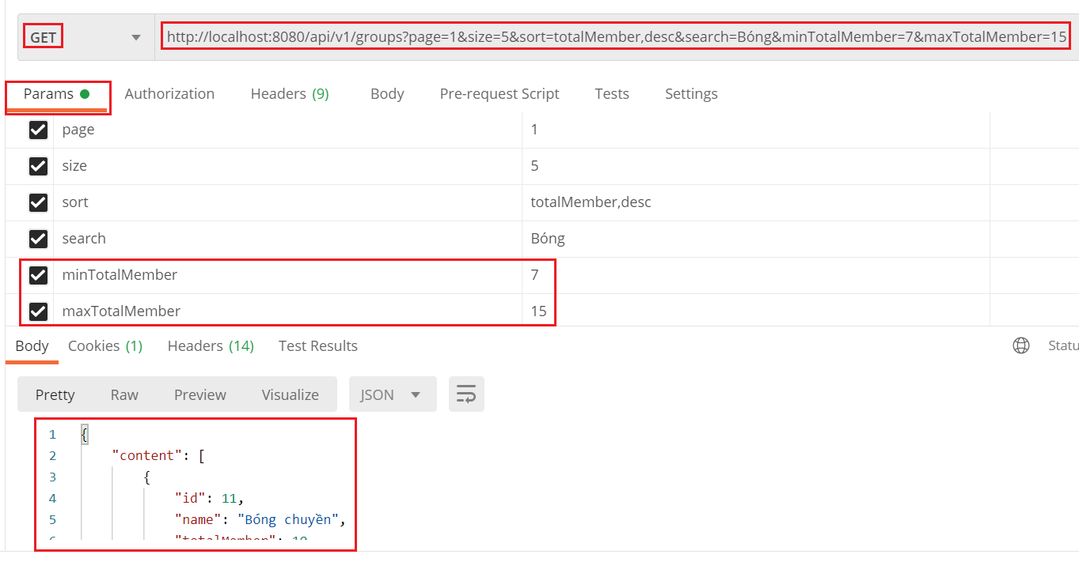

*Đính kèm Token vào header để get groups*

* **Frontend**

|  |  |
| --- | --- |
|  |  |

*Click vào button filter thì sẽ hiện ra*

* + Add Filter Button

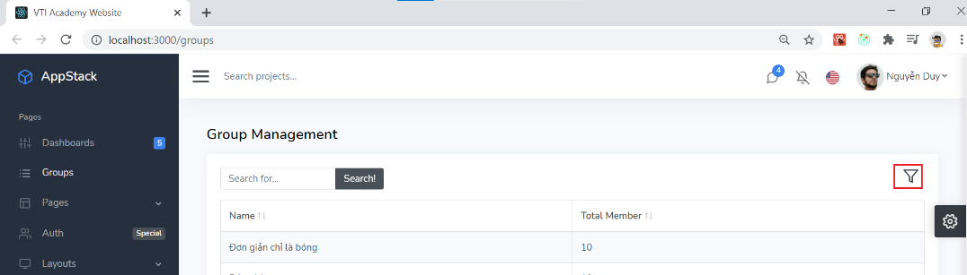

* + Filter box (Fieldset, Legend)

<https://stackoverflow.com/questions/16852484/use-fieldset-legend-with-bootstrap>

* + Basic filter (react-bootstrap-table2)

<https://react-bootstrap-table.github.io/react-bootstrap-table2/storybook/index.html?selectedKind=Column%20Filter&selectedStory=Text%20Filter&full=0&addons=1&stories=1&panelRight=0&addonPanel=storybook%2Factions%2Factions-panel>

* + Remote Filter

<https://react-bootstrap-table.github.io/react-bootstrap-table2/storybook/index.html?selectedKind=Remote&selectedStory=Remote%20All&full=0&addons=1&stories=1&panelRight=0&addonPanel=storybook%2Factions%2Factions-panel>

* + Custom Filter (react-bootstrap-table2)
    - <https://react-bootstrap-table.github.io/react-bootstrap-table2/storybook/index.html?selectedKind=Column%20Filter&selectedStory=Custom%20Filter&full=0&addons=1&stories=1&panelRight=0&addonPanel=storybook%2Factions%2Factions-panel>
    - <https://react-bootstrap-table.github.io/react-bootstrap-table2/storybook/index.html?selectedKind=Column%20Filter&selectedStory=Advance%20Custom%20Filter&full=0&addons=1&stories=1&panelRight=0&addonPanel=storybook%2Factions%2Factions-panel>
    - <https://stackblitz.com/edit/react-55g1xe?file=index.js>
  + Lưu lại Filter khi ẩn hiện
  + Fix Formik không re-render theo redux

<https://github.com/formium/formik/issues/1190>

* **Reference**